
The Arts Society North West Area Support Team
Day of Special Interest with Marc Allum
Friday 27th March 2026 at Clitheroe Golf Club
North West
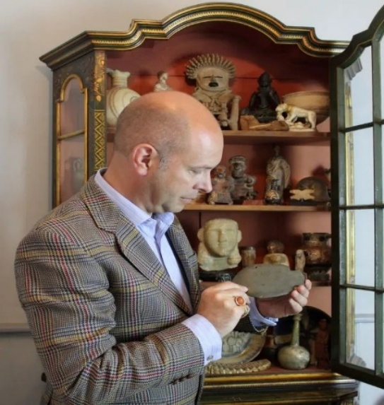
Marc is a freelance art and antiques journalist, writer and broadcaster. He has appeared on numerous television and radio programmes and is a miscellaneous presenter for the
Antiques Roadshow.
Marc has his own unique style, with interests ranging from pre-history to modern design.
He has a passion and reputation for discovering the unusual.

Programme
10.00-10.30 Registration and coffee
10.30-11.30 The Anatomy of Collecting
The history of collecting and the great collectors through time. Marc will include examples from his own treasures.
11.45-12.45 Fakes and Forgeries
Citing some of the greatest exponents in history and illustrated with a plethora of challenging examples. You are never going to look at art antiques in the same way again.
12.45-2.25 Buffet Lunch
2.30-3.30 Bring an Object
A spontaneous talk with objects brought in by attendees, no matter what the value. An instant ‘Antiques Roadshow’ of history, anecdotes and audience participation, interspersed with artefacts from Marc’s own collection.
Cost:£42
**********************************************************************************************
The Arts Society North West Day of Special Interest with Marc Allum
Name/s………………….……………………………………..………………Mobile no……………………………………….
Email…………………………………………………………………………………………………………………………………..
Dietary requirements……………………………………………………………………………………………………………
Payment to: The Arts Society North West CAF BANK Sort Code 40-52-40 Account no. 00060405
Use DOSI and your surname as a reference OR cheque payable to The Arts Society North West
Return booking form to barbarabooth3@outlook.com or with a cheque to:
Mrs B Booth 3 Marsden Fold Nelson BB9 0ET Mobile 07986087035
Your payment is not refundable unless your place can be filled from a waiting list or the event is cancelled. The Arts Society cannot be held responsible for any personal accident, loss, damage or theft of members’ personal property. Members are covered against proven liability to third parties.

